Demonstration of WEB IDE using Git Lab

Create a new folder on desktop

open gitbash

copy the folder path

cd paste the path

ls

git init

git status

ls

git add .

git status

git commit -m "any text"

git status

git remote addd origin Http link

git lab select create merge request

then scroll down and select create.

click on merge

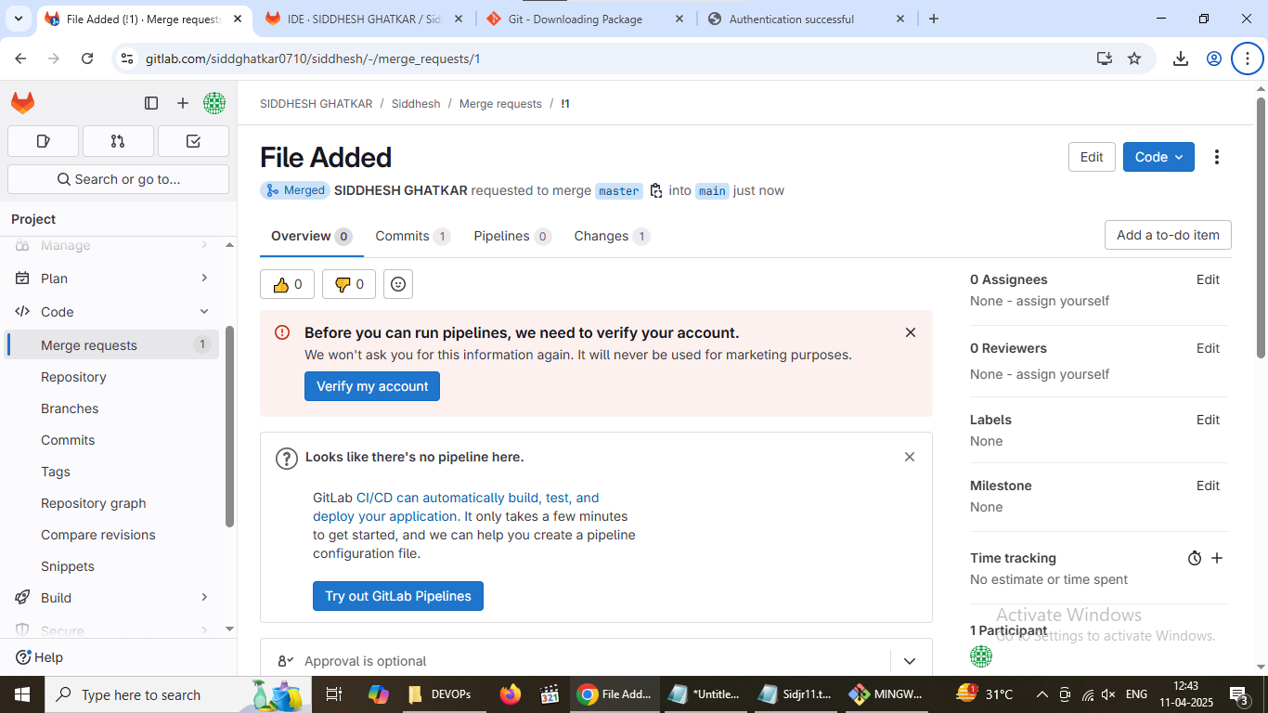

Clone

Create a new folder on desktop

Copy the path of that folder

Open git bash

Cd (paste the path)

Git clone Rep link

Git status